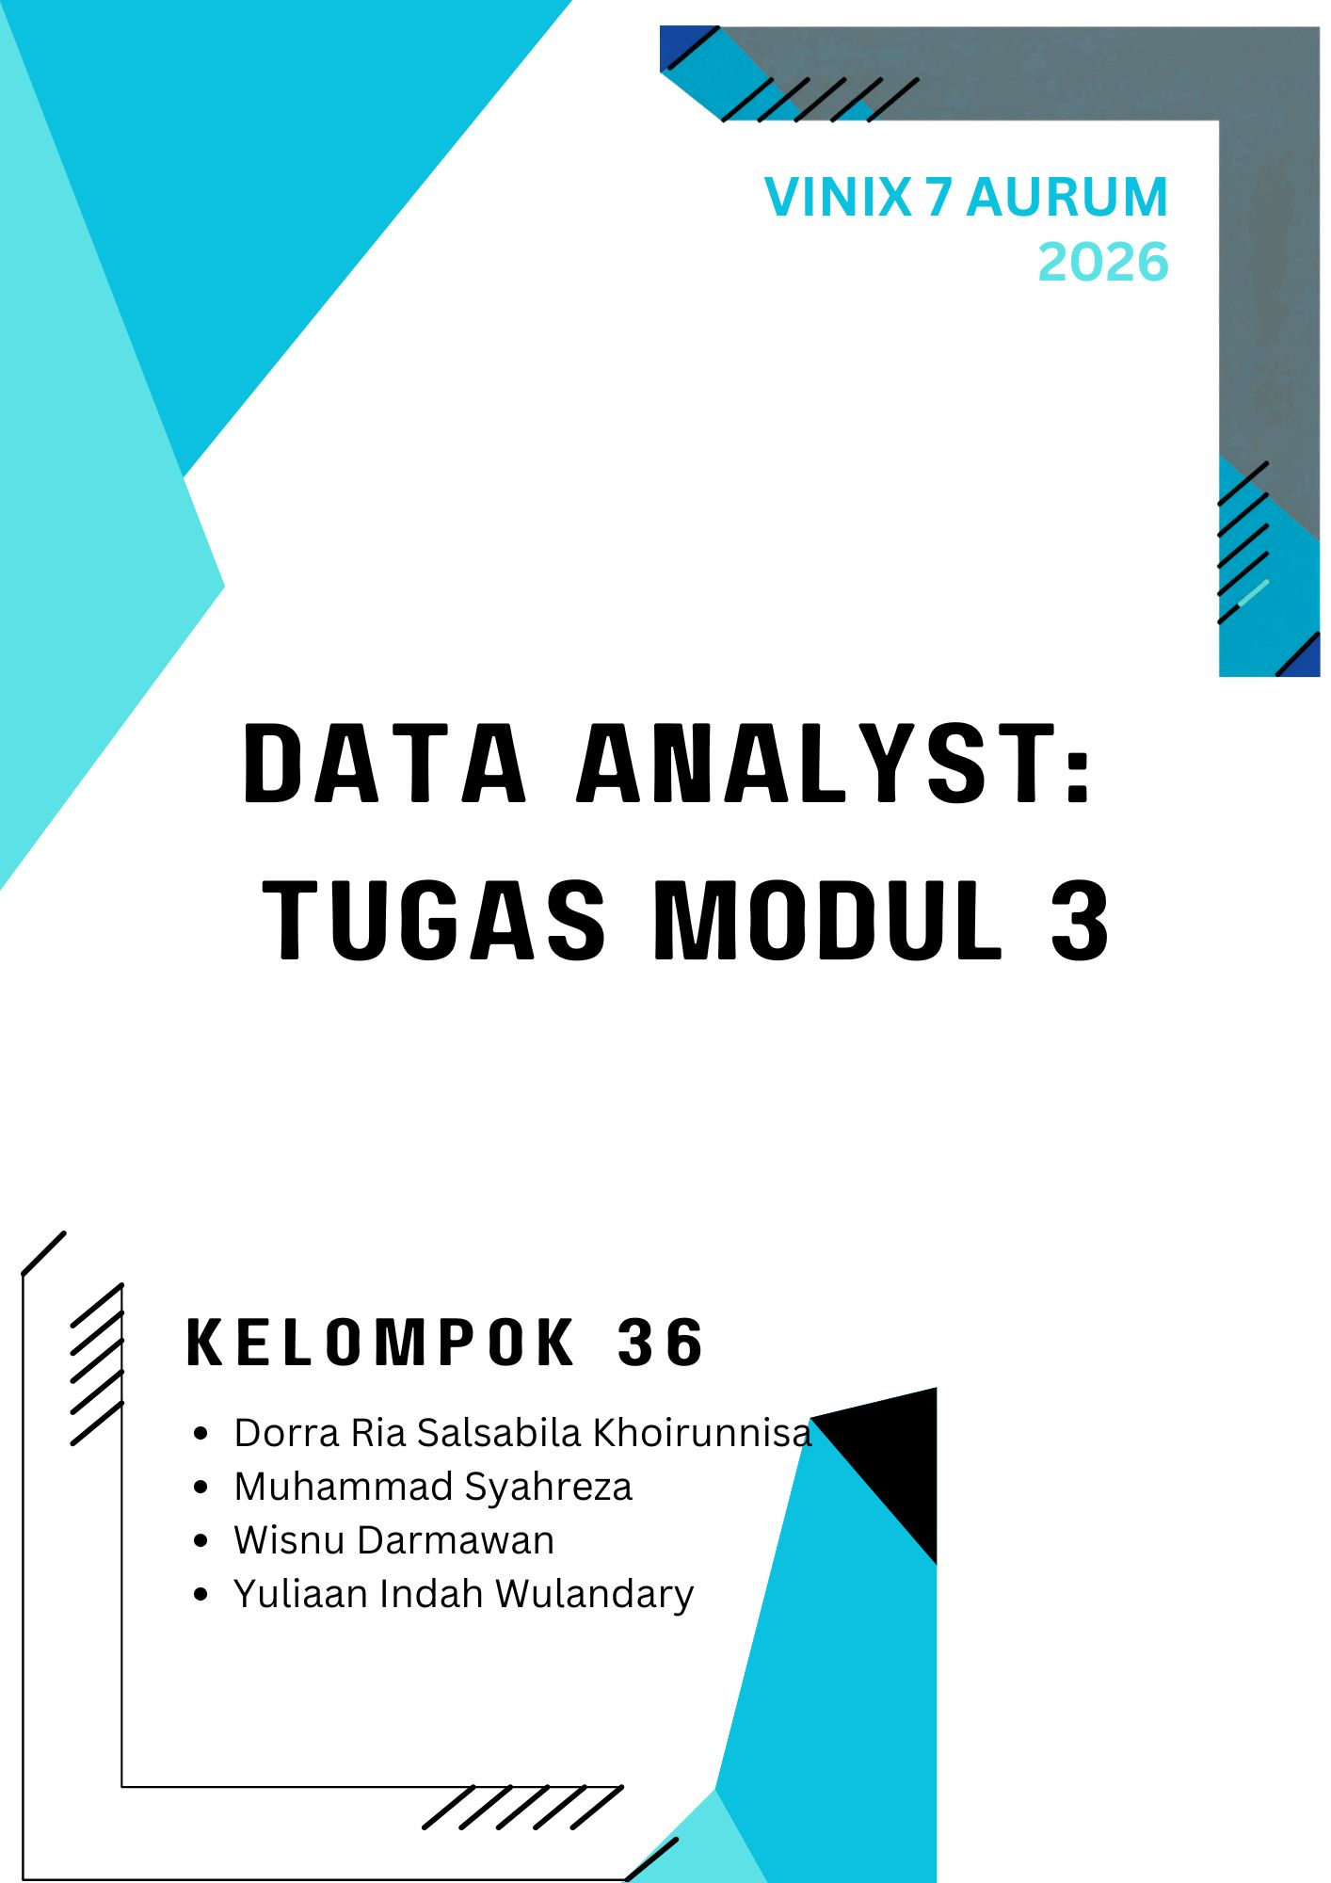
EXCEL DATA ANALYST
HR Performance Data Preparation
Executive Report - Data Audit, Cleaning, Wrangling, Integration & Pivot Insights
Executive Summary

1,020 | 996 | 184 | 43
Employee rows | Valid salary | Underpaid | Priority review
- Dari 996 employee dengan salary valid: 530 Standard (53.2%), 282 Overpaid (28.3%), dan 184 Underpaid (18.5%).
- DevOps memiliki 90 Underpaid (48.9% dari salary-valid DevOps) dan Cloud Tech 63 (44.7%). Admin memiliki 106 Overpaid (65.8%), sementara HR 85 (50.9%).
- Terdapat 43 employee dengan kombinasi Performance = Excellent dan Compensation_Status = Underpaid: 23 DevOps, 10 Finance, 10 Cloud Tech.
- Average salary antar performance category relatif berdekatan: Good $86.34k, Excellent $85.04k, Poor $85.04k, Average $84.19k. Angka ini bersifat high-level dan belum mengontrol department/job level.

Management action Audit salary band dan role/job-level composition terutama pada DevOps, Cloud Tech, Admin, dan HR. Untuk 43 priority cases, validasi job level, tenure, contract type, dan effective date salary band sebelum keputusan individual.

BEFORE CLEANING
Data Audit Summary
Audit mempertahankan grain 1 row = 1 employee dan menggunakan Employee_ID sebagai identifier utama. Tidak ada row yang dihapus hanya karena email berulang; anomaly dipisahkan dari duplicate employee.

Check | Actual finding | Treatment / control
Row count | 1,020 employee rows | Kontrol utama; harus tetap 1,020 sampai integration.
Employee_ID | 0 missing; 1,020 unique | Primary row identifier.
Age | 211 missing (20.7%) | Biarkan blank + flag MISSING; tidak diimputasi tanpa business rule.
Salary | 24 missing (2.4%) | Biarkan blank; excluded dari compensation classification.
Join_Date | 1,020 source values berupa text date | Dikonversi eksplisit menjadi real Excel date.
Phone | 1,020 source values bertanda negatif | ABS + TEXT; sign correction didokumentasikan.
Email | 64 unique untuk 1,020 Employee_ID | Flag REVIEW; tidak menghapus employee row.
Department_Region | 36 kombinasi gabungan | Dipisah menjadi Department dan Region.
Salary lookup | 6 departments; coverage lengkap | Target lookup miss = 0.

TABULAR EVIDENCE
Sample Evidence - Before vs After

Employee_ID | Field | Before (RAW) | After | Rule applied
EMP1001 | Age | (blank) | (blank) | Preserve missing + Age_Quality = MISSING
EMP1000 | Join_Date | 4/2/2021 (text) | 2021-04-02 (date) | Explicit DATE conversion
EMP1000 | Phone | -1651623197 | 1651623197 | ABS + TEXT; identifier preserved
EMP1000 | Department_Region | DevOps-California | DevOps | California | Split into atomic dimensions

Data governance RAW dipertahankan immutable. Cleaning memperbaiki representasi deterministik dan menandai missing/anomaly tanpa mengarang nilai yang tidak tersedia.

FORMULA-AUDITABLE
Methodology - Cleaning
Setiap transformasi dibuat formula-driven agar reviewer dapat menelusuri RAW -> CLEANING. Missing Age/Salary tetap blank; quality flags dipakai untuk memisahkan issue data dari row yang valid untuk analisis lain.

Field | Formula (current workbook) | Logic
Employee_ID | =TRIM(CLEAN(RAW!B2)) | Menghapus hidden spaces/control characters tanpa mengubah identifier.
First_Name | =PROPER(TRIM(CLEAN(RAW!C2))) | Standardisasi case dan whitespace.
Age | =IF(RAW!E2="","",IFERROR(VALUE(RAW!E2),"")) | Blank dipertahankan; nilai valid dipastikan numeric.
Join_Date | =IFERROR(DATE(VALUE(RIGHT(RAW!H2,4)),VALUE(LEFT(RAW!H2,FIND("/",RAW!H2)-1)),VALUE(MID(RAW!H2,FIND("/",RAW!H2)+1,FIND("/",RAW!H2,FIND("/",RAW!H2)+1)-FIND("/",RAW!H2)-1))),"") | Mengubah M/D/YYYY text menjadi Excel date secara eksplisit.
Salary | =IF(RAW!I2="","",IFERROR(VALUE(RAW!I2),"")) | Blank dipertahankan dan numeric type dinormalisasi.
Email | =LOWER(TRIM(CLEAN(RAW!J2))) | Lower-case + trim agar duplicate review konsisten.
Phone | =IF(RAW!K2="","",TEXT(ABS(VALUE(RAW!K2)),"0")) | Menghapus negative sign dan menyimpan phone sebagai text.
Remote_Work | =IF(RAW!M2=TRUE,"Yes","No") | Boolean menjadi label business-friendly.

Data Quality Flags
Flag | Formula
Age_Quality | =IF(D2="","MISSING","OK")
Salary_Quality | =IF(H2="","MISSING",IF(H2<=0,"INVALID","OK"))
Email_Duplicate_Review | =IF(COUNTIF($I$2:$I$1021,I2)>1,"REVIEW","OK")
Phone_Quality | =IF(RAW!K2<0,"SIGN_FIXED","OK")
Row_Quality | =IF(OR(M2<>"OK",N2<>"OK"),"REVIEW","OK")

Validation Expected controls dari workbook: 211 Age missing, 24 Salary missing, 64 unique emails, 0 phone negatif setelah cleaning, dan total row tetap 1,020.

FORMULA-AUDITABLE
Methodology - Cleaning
Setiap transformasi dibuat formula-driven agar reviewer dapat menelusuri RAW -> CLEANING. Missing Age/Salary tetap blank; quality flags dipakai untuk memisahkan issue data dari row yang valid untuk analisis lain.

Field | Formula (current workbook) | Logic
Employee_ID | =TRIM(CLEAN(RAW!B2)) | Menghapus hidden spaces/control characters tanpa mengubah identifier.
First_Name | =PROPER(TRIM(CLEAN(RAW!C2))) | Standardisasi case dan whitespace.
Age | =IF(RAW!E2="","",IFERROR(VALUE(RAW!E2),"")) | Blank dipertahankan; nilai valid dipastikan numeric.
Join_Date | =IFERROR(DATE(VALUE(RIGHT(RAW!H2,4)),VALUE(LEFT(RAW!H2,FIND("/",RAW!H2)-1)),VALUE(MID(RAW!H2,FIND("/",RAW!H2)+1,FIND("/",RAW!H2,FIND("/",RAW!H2)+1)-FIND("/",RAW!H2)-1))),"") | Mengubah M/D/YYYY text menjadi Excel date secara eksplisit.
Salary | =IF(RAW!I2="","",IFERROR(VALUE(RAW!I2),"")) | Blank dipertahankan dan numeric type dinormalisasi.
Email | =LOWER(TRIM(CLEAN(RAW!J2))) | Lower-case + trim agar duplicate review konsisten.
Phone | =IF(RAW!K2="","",TEXT(ABS(VALUE(RAW!K2)),"0")) | Menghapus negative sign dan menyimpan phone sebagai text.
Remote_Work | =IF(RAW!M2=TRUE,"Yes","No") | Boolean menjadi label business-friendly.

Data Quality Flags
Flag | Formula
Age_Quality | =IF(D2="","MISSING","OK")
Salary_Quality | =IF(H2="","MISSING",IF(H2<=0,"INVALID","OK"))
Email_Duplicate_Review | =IF(COUNTIF($I$2:$I$1021,I2)>1,"REVIEW","OK")
Phone_Quality | =IF(RAW!K2<0,"SIGN_FIXED","OK")
Row_Quality | =IF(OR(M2<>"OK",N2<>"OK"),"REVIEW","OK")

Validation Expected controls dari workbook: 211 Age missing, 24 Salary missing, 64 unique emails, 0 phone negatif setelah cleaning, dan total row tetap 1,020.

OBJECTIVES B & C
Methodology - Wrangling & Integration
WRANGLING memisahkan field gabungan menjadi dimension atomic. INTEGRATION menggabungkan salary reference, lalu menerapkan conditional logic untuk compensation status, salary gap, dan priority compensation review.

Wrangling
Output | Formula (current workbook) | Logic
Department | =TRIM(LEFT(E2,FIND("-",E2)-1)) | Mengambil text sebelum dash pertama sebagai Department.
Region | =TRIM(RIGHT(E2,LEN(E2)-FIND("-",E2))) | Mengambil text setelah dash pertama sebagai Region.

Integration & Conditional Logic
Output | Formula (latest) | Business logic
Minimum_Salary | =XLOOKUP([@Department],tblSalary[Departmen],tblSalary[Minimum_Salary],"",0) | Exact-match salary minimum; blank jika lookup tidak ditemukan.
Maximum_Salary | =XLOOKUP([@Department],tblSalary[Departmen],tblSalary[Maximum_salary],"",0) | Exact-match salary maximum.
Compensation_Status | =IF([@Salary]="","Review - Missing Salary",IF(OR([@Minimum_Salary]="",[@Maximum_Salary]=""),"Review - Lookup",IF([@Salary]<[@Minimum_Salary],"Underpaid",IF([@Salary]>[@Maximum_Salary],"Overpaid","Standard")))) | Versi terbaru: missing salary dicek lebih dulu, lalu lookup miss, baru band comparison. Label final "Standard" tanpa typo.
Salary_Gap_To_Min | =IF([@Salary]="","",[@Salary]-[@Minimum_Salary]) | Versi terbaru: blank salary tetap blank; nilai negatif berarti di bawah minimum.
Salary_Gap_To_Max | =IF([@Salary]="","",[@Salary]-[@Maximum_Salary]) | Versi terbaru: blank salary tetap blank; nilai positif berarti di atas maximum.
Critical_Talent_Flag | =IF(AND([@Performance_Score]="Excellent",[@Compensation_Status]="Underpaid"),"High Priority Retention Review","Normal") | Versi terbaru: menandai Excellent + Underpaid sebagai prioritas review, bukan prediksi attrition.

Auditability Salary reference tetap 6 department dan header source "Departmen" dipertahankan. Hasil klasifikasi terverifikasi: Standard 530, Overpaid 282, Underpaid 184, Review - Missing Salary 24, Review - Lookup 0.

HIGH-LEVEL MANAGEMENT INSIGHTS
Results - Pivot Analysis
PivotTable menggunakan tblIntegration sebagai source. Compensation analysis mengecualikan 24 missing salary dari perbandingan band, sehingga n salary-valid = 996.
Department | Underpaid | Standard | Overpaid | Valid salary
Admin | 0 | 55 | 106 | 161
Cloud Tech | 63 | 78 | 0 | 141
DevOps | 90 | 94 | 0 | 184
Finance | 31 | 108 | 29 | 168
HR | 0 | 82 | 85 | 167
Sales | 0 | 113 | 62 | 175
Grand Total | 184 | 530 | 282 | 996

Reading Underpaid concentration tertinggi berada di DevOps (48.9%) dan Cloud Tech (44.7%). Overpaid concentration paling menonjol di Admin (65.8%) dan HR (50.9%).

PIVOT OUTCOME
Results - Performance & Priority Review

Performance | Average Salary | Valid Salary n
Excellent | $85,044.75 | 260
Good | $86,338.76 | 260
Average | $84,190.40 | 263
Poor | $85,035.91 | 213

Interpretation Average salary tidak membentuk pola monotonic mengikuti performance label. Ini belum membuktikan hubungan kausal karena department, job level, tenure, dan market band tidak dikontrol.

Priority Compensation Review
Department | Excellent + Underpaid
DevOps | 23
Finance | 10
Cloud Tech | 10
Total | 43

Use of result 43 employee memenuhi kombinasi Excellent + Underpaid: 23 DevOps, 10 Finance, dan 10 Cloud Tech. Gunakan hasil ini sebagai shortlist compensation review, bukan sebagai label attrition risk.

REPORTING QUALITY
QA, Limitations & Recommended Actions
Control | Status | Evidence / note
Row integrity | PASS | RAW, CLEANING, WRANGLING, dan INTEGRATION mempertahankan 1,020 employee rows.
Employee_ID uniqueness | PASS | 1,020 unique Employee_ID; tidak ada duplicate employee identifier.
Salary lookup coverage | PASS | Semua 6 department ter-cover; Review - Lookup = 0.
Compensation total | PASS | 184 + 530 + 282 + 24 = 1,020.
Priority flag | PASS | Excellent + Underpaid = 43.
Pivot 2 count field | NOTE | Workbook Pivot 2 menampilkan Count of Employee_ID = 1,020 karena count tersebut tetap menghitung employee dengan salary blank, sedangkan Average Salary otomatis memakai 996 salary nonblank. Di laporan ini sample size valid salary ditampilkan sebagai 996 untuk menghindari ambiguity.

Limitations
- Dataset tidak menyediakan job level, role grade, tenure-derived business rule, market benchmark, atau salary-band effective date; penyebab misalignment tidak boleh dianggap pasti.
- Duplicate email pattern (64 unique email untuk 1,020 Employee_ID) memerlukan konfirmasi business/source-system; tidak digunakan sebagai dasar penghapusan row.
- Critical_Talent_Flag adalah priority compensation review signal, bukan prediksi resign/attrition.
- Screenshot RAW/CLEANING/WRANGLING/INTEGRATION sengaja tidak dimasukkan sesuai instruksi; audit evidence diganti dengan tabel before/after dan formula dictionary.

Recommended Next Steps
# | Action | Purpose
1 | Validate salary policy | Konfirmasi bahwa salary band reference masih current dan sesuai job level.
2 | Review priority cases | Mulai dari 43 Excellent + Underpaid; DevOps memiliki volume terbesar.
3 | Improve source controls | Enforce date type, phone-as-text, salary completeness, dan email uniqueness rule bila memang diwajibkan.
4 | Add segmentation | Lanjutkan analisis dengan job level, tenure, contract type, dan location/market benchmark untuk keputusan yang lebih presisi.

Conclusion Workbook sudah menunjukkan alur yang dapat diaudit dari RAW -> CLEANING -> WRANGLING -> INTEGRATION -> AGGREGATION, dengan formula current workbook dan hasil Pivot yang dapat ditelusuri kembali ke employee-level data.

L A M P I R A N

- Data Mentah

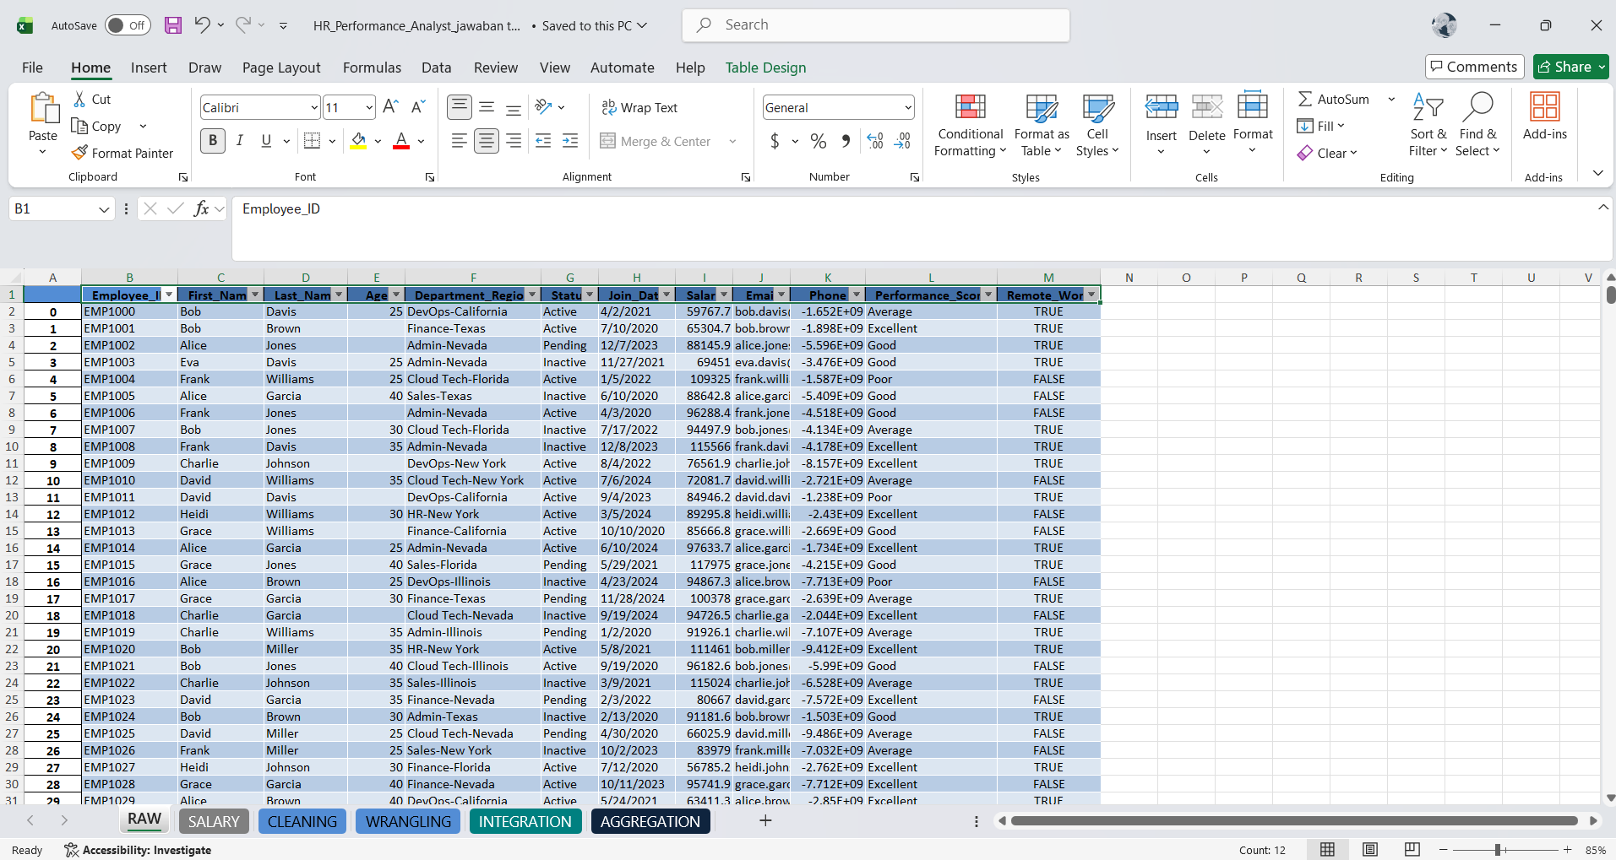

- Cleaning Data
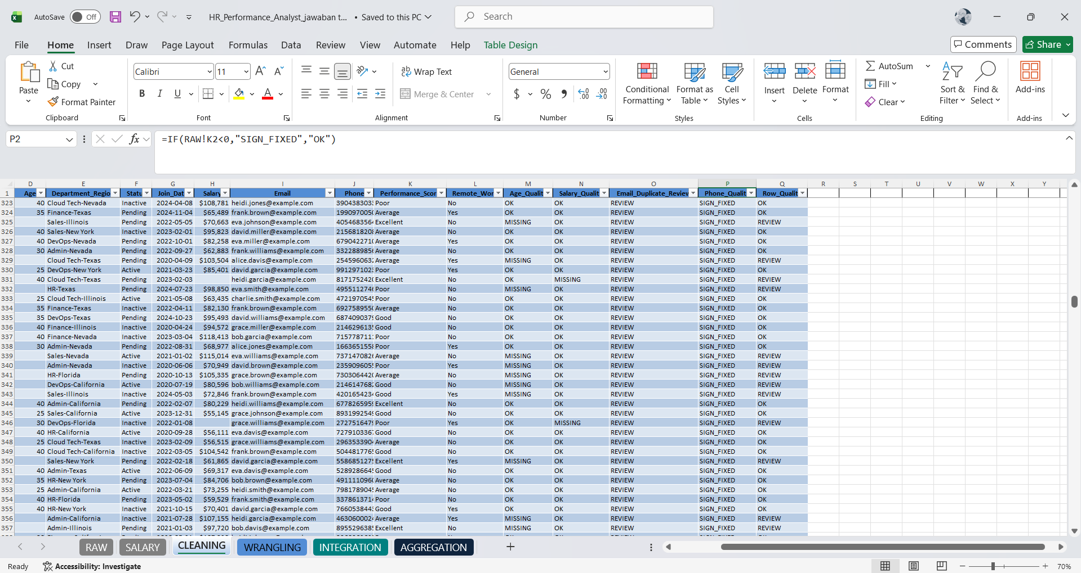

- Wrangling Data
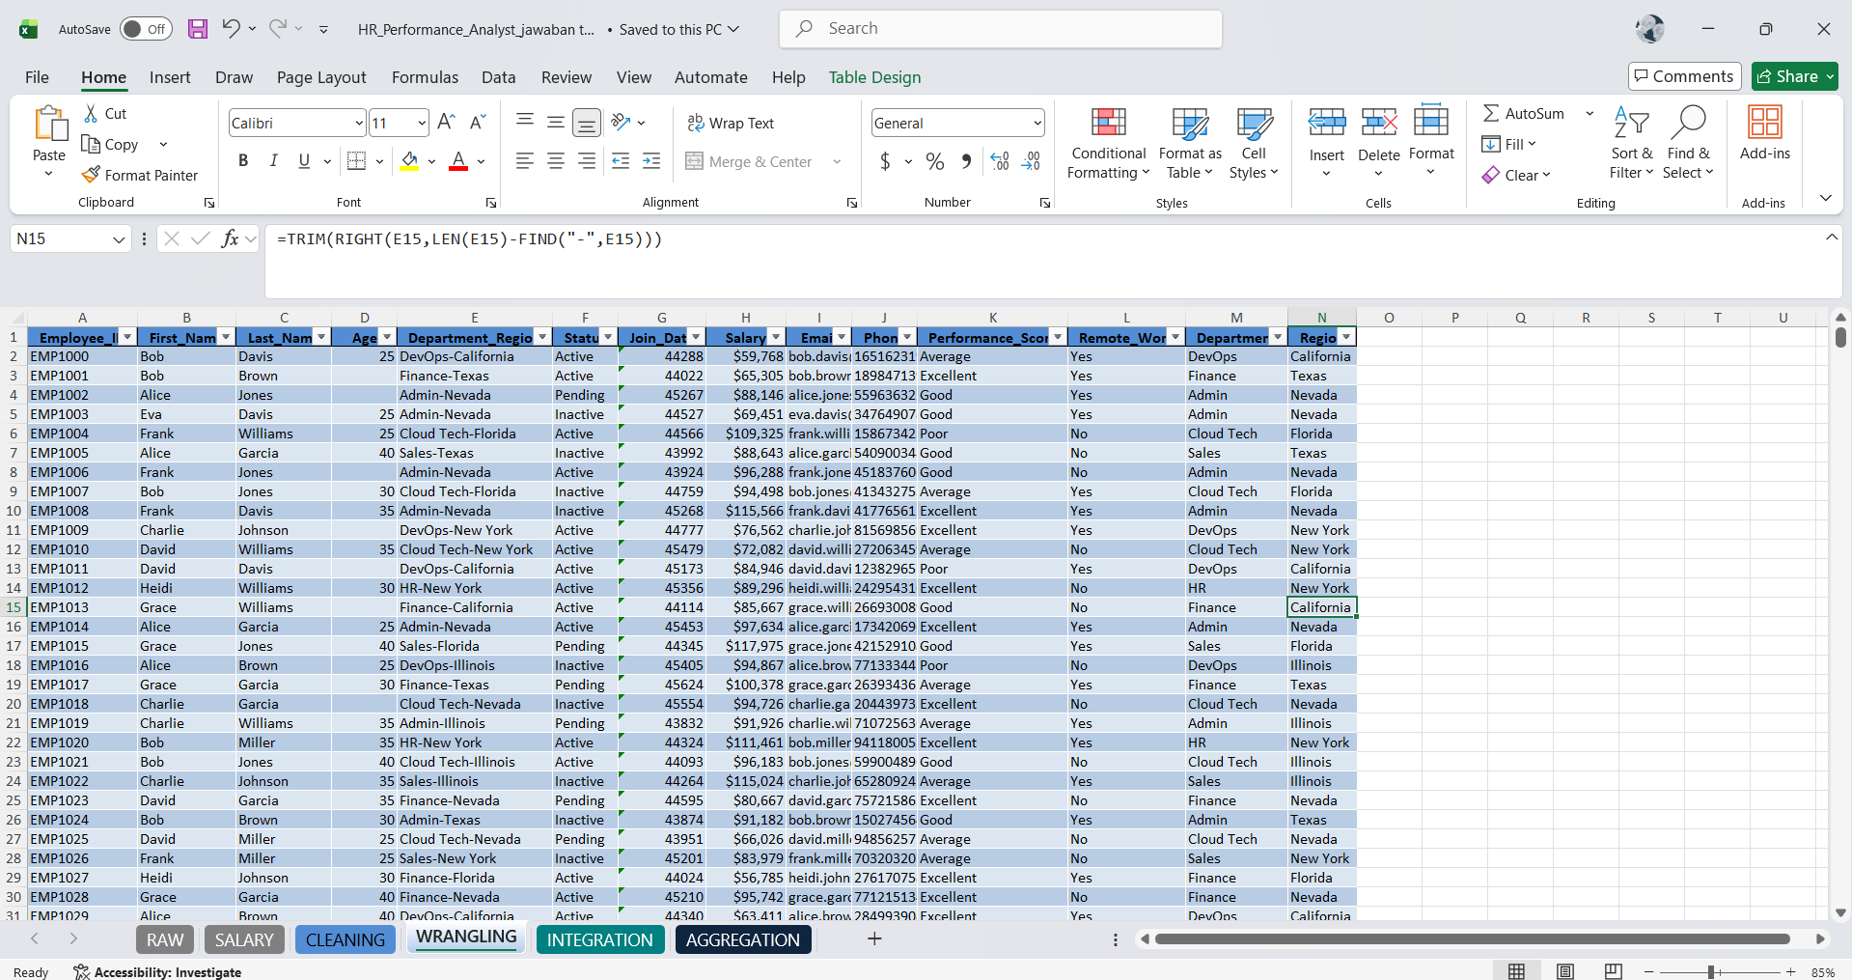

- Data Integration
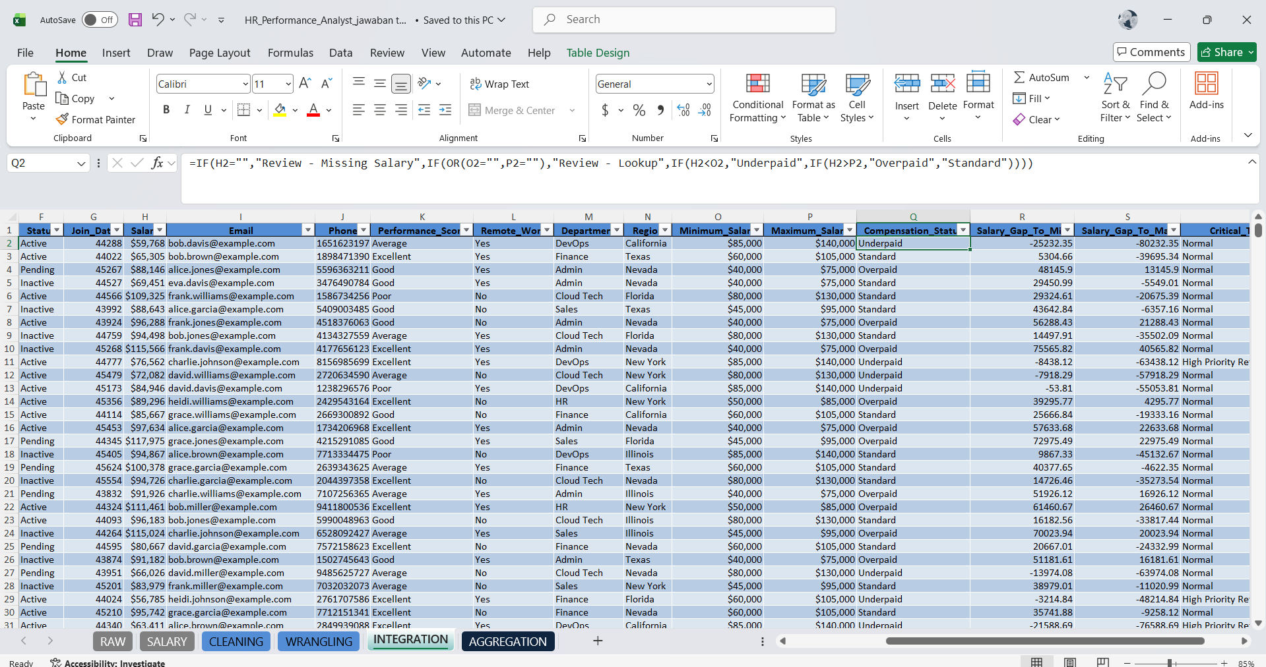

- Pivot Table


